Q1. How would you analyze the relationship between Bitcoin's closing price and its trading volume over the past 8 years? Please explain your approach to extracting relevant data and visualizing any trends or patterns.

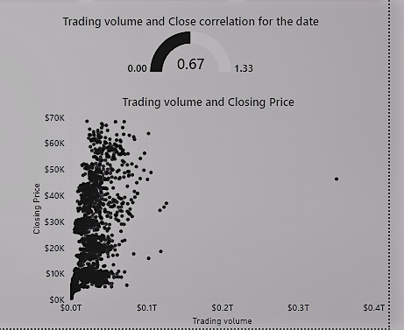

Answer- My approach

* I loaded the dataset using the Microsoft PowerBi, I noticed the Date provided was more than 8 years so I created a slicer to Filter and Visualize my date so I can have the last 8 years on my Analysis.
* I used Scatter Plot and Correlation Coefficient to analyze the relationship between the trading volume and closing price in the last 8 years

The plot illustrates how the trading volume correlates with the closing price of Bitcoin. Each point represents a day's trading volume and its corresponding closing price.

The correlation coefficient between Bitcoin's closing price and trading volume is **0.6657.**

This positive correlation coefficient suggests a moderate positive relationship between Bitcoin's closing price and its trading volume. In other words, as the trading volume increases, the closing price of Bitcoin tends to increase as well, and vice versa.

Q2. Can you describe how you would calculate and interpret the exponential moving averages (EMAs) for Bitcoin's closing price based on historical data? How might you visualize these EMAs alongside the actual closing prices to identify potential buy or sell signals?

Answers

EMAs are common signal used in Technical Analysis and common periods include 12-day and 26-day for short-term trends, and 50-day and 200-day for long-term trends. This implies that the ema_50 and ema_100 present in our dataset is for a **long term trend** of course more than **8 years**

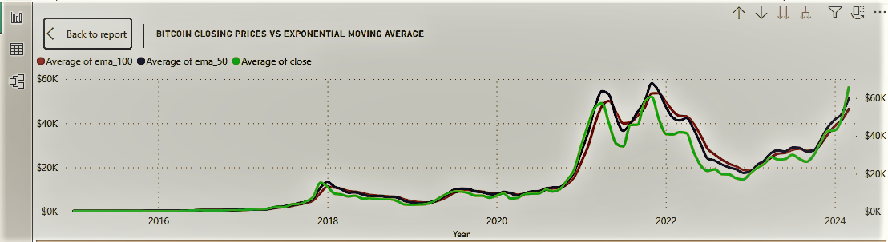

EMAs can act as levels of support or resistance for the price(GREEN). When the price is above the EMA, the EMA can act as a **support level**, and when the price is below, it can act as a **resistance level**.

This indicate that whenever the green line is above both the red and blue line as indicated by the arrow, the red and dark blue line will behave as a support and when the green line which is the price, crosses/breaks the support we automatically have a retracement or a fall in price as indicated on the orange curve.

Checking some part of 2021 the price crosses above the EMAs even though it was slightly we immediately experience an upward trend towards early 2022 this is exactly how we can predict the price BTC using the exponential moving average EMAs.

3. Given the dataset's technical indicators like the MACD (Moving Average Convergence Divergence) and Bollinger Bands, how would you identify instances where the MACD line crosses above or below the signal line? Describe your method for visualizing these instances to inform trading decisions.

Q4. what strategies would you employ to assess Bitcoin’s price volatility using provided datasets? Explain how you would calculate and interpret indicators, such as average true range(ATR) over different time periods and visualizes these values for analysis.

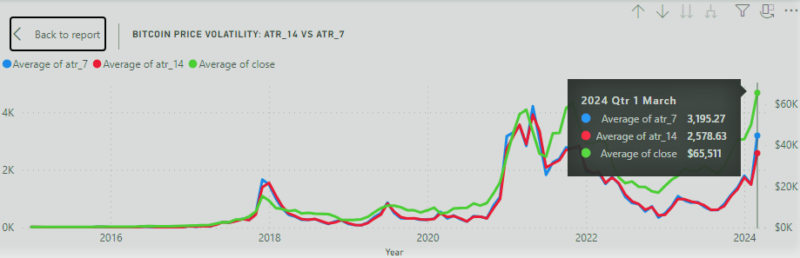

**Answer**: Average True Range (ATR): The ATR is a technical analysis indicator that measures market volatility by decomposing the entire range of an asset price for that period. The dataset includes ATR values for 7 and 14 periods, which we can use to assess volatility over these time frames.

This chart shows the ATR values over time, providing insights into the volatility of Bitcoin's price. The ATR is a measure of market volatility, with higher values indicating greater volatility. By comparing the ATR for 7 days and 14 days, we can observe how volatility changes over these different time periods. This information can be valuable for making informed trading decisions, especially in identifying periods of high volatility which might present trading opportunities or risks.

5. Could you explain your approach to detecting significant deviations in Bitcoin's closing price from its Simple Moving Average (SMA) over a 50-day period? How might you visualize these deviations and evaluate their impact on trading strategies?

**Answer:** To detect significant deviations in Bitcoin's closing price from its Simple Moving Average (SMA) over a 50-day period, I calculated the difference between the closing price and the 50-day SMA which was done in a new column entirely and I calculated the standard deviation using the function STDEV.P on my power query editor, Positive deviations indicate the closing price is above the SMA, while negative deviations indicate it is below. Visualizing these deviations can be shown clearly by plotting the Standard deviation of closing price along and the SMA over a particular period of time and highlighting the points where significant deviations occur. Using the data labels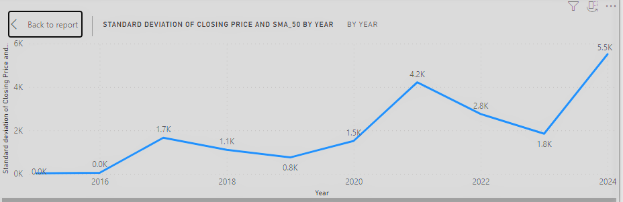

Note from the chart above upward trends indicate a positive deviation while a downward trend indicate a negative deviation which by analyzing the significant deviations, we can gain insights into the market behavior and identify potential trading opportunities or risk factors. These deviations can help identify potential trading opportunities based on the price movements relative to the SMA

As shown blow Using the Crossover strategy, anytime the blue line cross the orange line downward market is definitely going to drop (Bearish) and if it crosses above its definitely a bullish signal

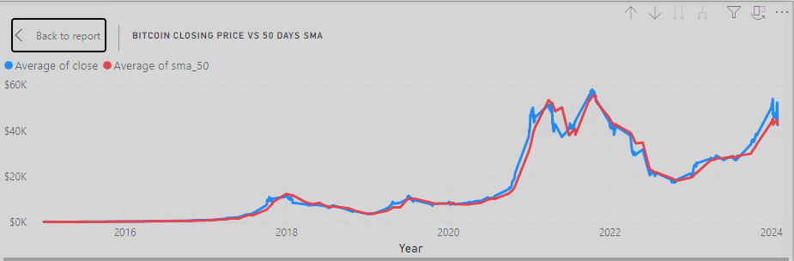

Bearish

Bearish

Bullish

Bullish

Trend Following Strategy: Traders may interpret a price above the SMA as a bullish signal and a price below the SMA as a bearish signal, following the trend until a reversal is indicated.

Crossover Strategy: Traders may use the crossover of the price and the SMA (e.g., when the price crosses above the SMA) as a signal to enter or exit trades.

6. Suppose you were tasked with preparing a report on the performance of Bitcoin based on the provided dataset. How would you structure the report to effectively communicate key metrics, trends, and potential opportunities or risks to stakeholders?

To prepare a report on the performance of Bitcoin based on the dataset, the structure will include

* Introduction to Bitcoin and the dataset
* Key metrics such as price trends, volatility, and trading indicators
* Analysis of trends over time, including moving averages and technical indicators as have done in my PowerBI report
* Potential opportunities and risks for investors
* Conclusion with recommendations for stakeholders

7. Imagine you need to present findings on Bitcoin's volatility using the dataset. How would you approach visualizing volatility trends over time, and what additional context or analysis would you include in your presentation to ensure stakeholders have a comprehensive understanding of the topic?

When presenting findings on Bitcoin's volatility using the dataset, I will visualize volatility trends over time by plotting metrics like ATR (Average True Range) or historical volatility. Additional context could include comparing Bitcoin's volatility to other assets, analyzing the impact of news events on volatility, and discussing the implications of volatility for trading strategies and risk management.